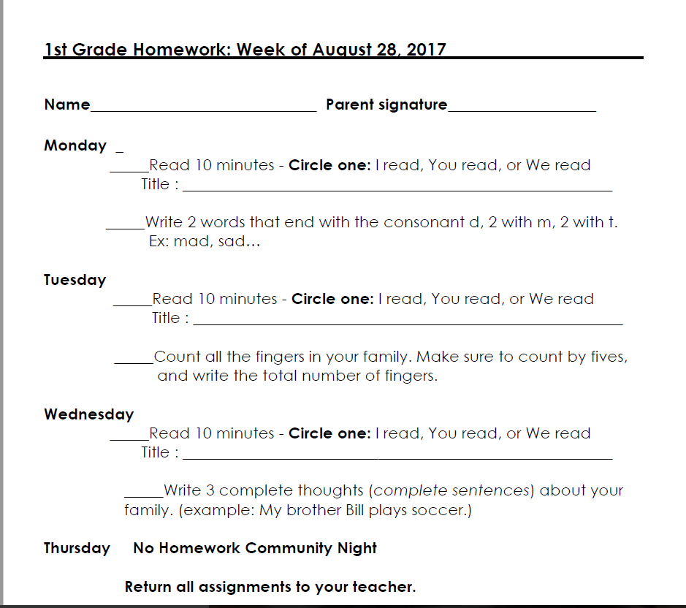

**1st Grade Homework: Week of August 27, 2018**